

Selecting a Topic and Conducting a Library Database Search

The work you begin in Module 1 of this course will provide the foundation for your Final Course Project, which will be submitted in Module 5. The focus of this course is to establish how you, as a practitioner, can utilize research to inform your understanding of evidence-based practices in the field of counseling and beyond. Therefore, Assignment 1 is to select a counseling related topic and to be able to document this process so that your work is transparent and replicable.
Before you can search the library databases, consider some potential topic areas in the counseling field. Johnson and Christensen (2014) propose that literature reviewers begin by exploring everyday life, practical issues, or past research. In fact, by creating a type of “bank” of literature on any given topic, the literature reviewer is an original thinker— combining some type of knowledge with original thoughts for an original, purposeful and logical argument.
It is probable that there is a general topic area in mind to research. It is also important to consider your field of interest and the collective need-to-know to by researching articles that are timely for the helping profession. By approaching the selection of a topic via considering your field of interest and the counseling community needs, you will build the body of knowledge for future research. The following figure adapted from Onwuegbuzie and Frels (2015) conceptualization for selecting a topic might assist you in brainstorming a tentative topic for the final course project, which begins by completing Assignment 1.

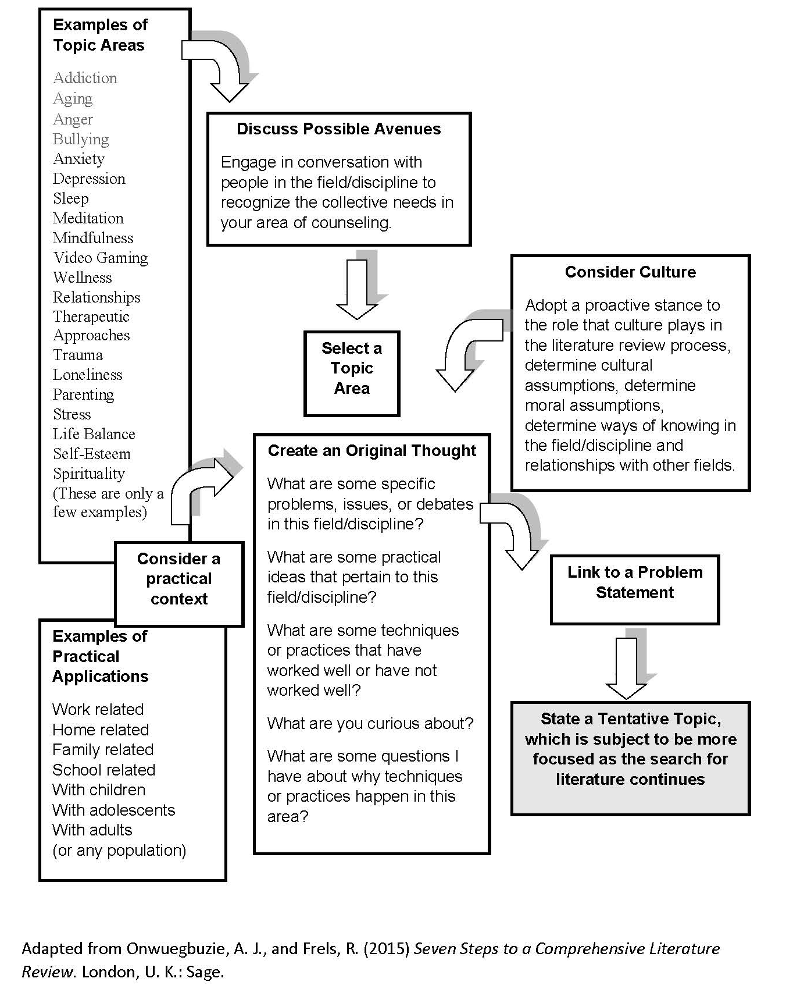

A topic area also might stem from practical problems that you encounter in your everyday work environment, with the search for solutions culminating in viable topics coming to the fore. Or, an attempt to address a practical problem in your home or familial environment might lead to potential topics emerging. Therefore, spending some time discussing your potential topic area with others in your field provides you not only with the needs of the community, but also with some of the hot topic areas. This discussion also will be helpful to you for thinking of some key

It is helpful to keep in mind the saying “know thyself,” which is a philosophical exploration of how your see and understand the world and human condition. Your worldview includes values, experiences, interests, and beliefs about how knowledge is acquired. Through reflexivity, which includes your awareness of these attributes, you can begin to negotiate your own biases inherent in your comprehensive literature review. These ideas help to summarize your topic selection and search:
- Philosophical thinking moves us to look into the thinking that forms our beliefs and their logical connections with other beliefs.
- Worldview is a philosophical stance that provides a basic set of beliefs for guiding a literature reviewer’s actions and includes research beliefs, discipline- specific beliefs, and topic-specific beliefs.
- Cultural awareness includes maintaining a high degree of self-awareness for understanding how your own background and other experiences might serve as assets or limitations when searching and interpreting literature and other sources of information, as well as striving to develop cultural awareness and beliefs, cultural knowledge, and cultural skills.
- You can negotiate an author’s bias and your own bias through keeping an open mind and critical reflection.
- By approaching the selection of a topic by considering your field of interest and the academic community, you will build the body of knowledge for future inquiry by other literature reviewers.
- The literature review is typically linked to a problem statement.
- Spending some time discussing your potential topic area with other academic scholars in your field is helpful.

This assignment should be a total of approximately 3-5 pages, not including the cover page, the template/chart, and references. Submit your reflection narrative report and chart/matrix in one Word document in APA sixth edition format to Blackboard. Be sure to include the references for each entry in the chart.

Directions

The goal of Assignment 1 is to familiarize you with the steps of conducting a library search for staying abreast of evidence-based practices in the field of counseling. The following information should help you to understand conducting the initial search.

There are six basic Boolean operations. The first three basic Boolean operations (i.e., AND, OR, AND NOT). The use of the OR Boolean operator greatly increased the number of hits, or results, relative to the use of the AND Boolean operator. This is always the case. Thus, the OR operator expands a search, whereas the AND operator narrows a search. The use of the NOT operator also greatly increases the number of hits; however, whether the AND NOT operator expands or narrows a search depends on the word or phrase that is being excluded from the search. Use of an asterisk expands the search, whereas use of quotation marks narrows a search. Finally, use of parentheses tends to narrow a search, especially when it is combined with the use of the OR operator on at least one occasion within the search string.

1. Conduct an electronic database search on ERIC, PsycINFO, or some other relevant database by going to the tab: Databases. State the topic and the database you have selected.

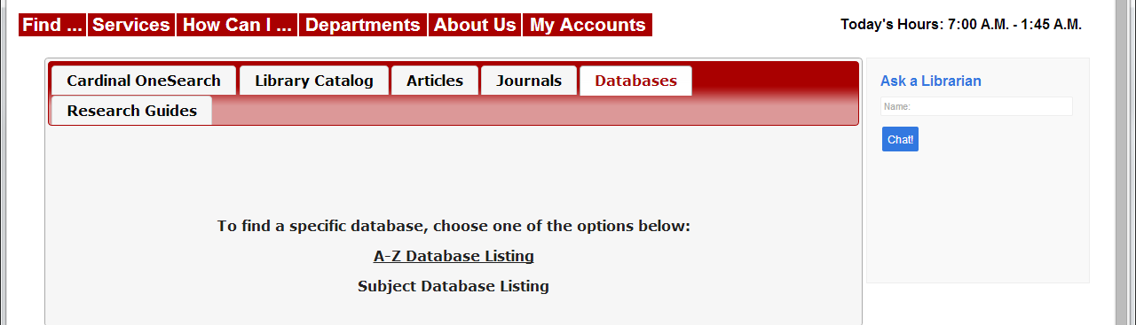

2. Document your search process, which is providing a transparent set of procedures as a type of audit trail. Too often students and researchers retrace their steps in doing literature searches. The purpose of this step is to get in the habit of keeping track of all your searches. For each step in your search, note your search terms and record how many references were returned as a function of how narrowly or broadly you defined your search. Use the chart at the end of this assignment.
Each time you broaden or narrow your search, scan through and get a rough estimate (if the search yields a manageable number of entries, you can get an exact count) of how many new hits you obtained. Document each time you focused the search. The following kinds of entries are possible: journal articles, conference presentations, unpublished manuscripts and dissertations, and non-English entries. However, each article will not be empirical research. You will need to peruse the abstracts and determine if the article is empirical research as well as to determine the method (qual, quan, mixed). Keep detailed notes.
3. Create a narrative report/reflection section of your library search process that includes: (a) decision process for selecting the topic; (b) challenges in your search; (c) new discoveries in the topic area and/or research process; (c) the template/chart in completion that notes the details documenting your search. Be sure to include the Audit Trail chart presented at the end of this document as the Appendix of your report. Then, compose your formal report for the assignment. Include the following sections:
Overview of Topic
Description and rationale for the topic as relating to the counseling field.
Audit Trail
Description of the search in a paragraph form, including the databases used the the journals selected for the chart.
Methodology
Description of quantitative, qualitative, and mixed research. Were the bulk of the empirical research studies in any specific tradition? Which articles resonated most with you and why?
Reflection
What was your initial impression as a whole of the bulk of research in your topic area? What are some of your own personal experiences relating to the topic? What surprised you? In what ways do you expect that continuing this line of inquiry might help establish best practices? What might you plan to do differently as you progress in your search?

Rubric for Grading (75 points)
Criteria | Meets Standard | Competent | Needs Improvement
 | 8 – 10 points | 5-7 points | 0 – 4 points
Topic and Evidence | Demonstrated clear rationale for topic selection and described in detail: context/population, research tradition, and method for at least 5 related articles using various methodologies | Demonstrated a rationale for topic selection and described in detail: context/population, research tradition, and/or method for 4 related or somewhat related articles using various methodologies | Demonstrated a weak rationale for topic selection and described in minor detail: context/population, research tradition, and/or method for less than 4 related or somewhat related articles using various methodologies
Audit Trail | Provided a thorough and accurate documentation of number of database hits for each search | Provided documentation of number of database hits for each search but the documentation is lacking depth or clarity | Documentation is sparse or not included
Methodology | Thoroughly described the methodology and the journals used for most of the understanding for the topic. | Described the methodology and the journals used for most of the understanding for the topic, however 25% or less of the articles have incorrect methodology identified. | Weakly described the methodology and the journals used for most of the understanding for the topic and/or more than 25% of the articles have incorrect methodology identified.
 | 11 – 15 points | 8 – 10 points | 0 – 4 points
Reflection | Provided a one-page narrative that includes all of the following: (a) limitations of the research for at least 5 of the articles, (b) personal experiences relating to the topic for future use in counseling, (c) supporting rationale for selecting the topic with several details. | Provided a one-page narrative that includes at least two of the following: (a) limitations of the research for at least 5 of the articles, (b) personal experiences relating to the topic for future use in counseling, (c) supporting rationale for selecting the topic with several details. | Provided a one-page (or less) narrative and/ or does not adequately address at least two of the areas: (a) limitations of the research for at least 5 of the articles, (b) personal experiences relating to the topic for future use in counseling, (c) supporting rationale for selecting the topic with several details.
Evidence | Summary chart is complete in all areas: context/population/geographical context, (b) topic of article, (c) tradition of research (quan, qual, mixed), (d) method of research, (e) personal memo/thoughts. 5 articles required | Summary chart is mostly complete in all areas: context/population/geographical context, (b) topic of article, (c) tradition of research (quan, qual, mixed), (d) method of research, (e) personal memo/thoughts. 5 articles required | Summary chart is missing or more than 50% of the required sections. Less than 5 articles used.
Writing Style | Writing is reflective of all areas: (a) critical examination with respect to culture and/or social norms, (b) reasoned reflections with respect to the field, (c) new ideas based on evidence/argument using sources. APA format is used and writing has no or few grammatical errors. | Writing is reflective of each area but might need expanding: (a) critical examination with respect to culture and/or social norms, (b) reasoned reflections with respect to the field, (c) new ideas based on evidence/argument using sources. APA format is used and writing has no or few grammatical errors, | Writing exhibits little reflection, requires extensive expansion of ideas, and/or has significant APA errors, grammatical errors and spelling errors.

Chart to document your search. Please add columns or rows as needed.
Search term(s)/Boolean operator(s): |  |  | Databases | Number of hits (Results) | Other Notes:
Title of Article | Journal | Year of Publication | Research Tradition (Quan,Qual, Mixed) | Method | Context: Participants, Population, Location | Key Points in Article

Search term(s)/Boolean operator(s): |  |  | Databases | Number of hits (Results) | Other Notes:
Title of Article | Journal | Year of Publication | Research Tradition (Quan,Qual, Mixed) | Method | Context: Participants, Population, Location | Key Points in Article

